
Policy Number
8

SEND Policy

Approved By: Ebor Academy Trust Board of Trustees

Approved by: Ebor Academy Trust Board of Trustees

Approval Date: November 2025

Review Period: Every three years or as and when changes occur in legislation

Review Date: November 2028

Author/Updated by: Deborah Meiklejohn (SEND Lead)
Date Created/updated: November 2025
Version Number: 8

Contents

1. Purpose and Aims 4
2. SEND Provision in School 4
3. Definitions 4
4. The Graduated Approach 5
5. Roles and Responsibilities 6
6. Admission Arrangements for Pupils with SEND 8
7. Accessibility 8
8. Medical Needs 9
9. Evaluating Success 9

Purpose and Aims

This policy is designed to sit alongside the SEND Information Report that is produced and maintained by individual academies. This policy aims to:

- Ensure that all stakeholders, including staff, governors, parents and carers understand the graduated approach to identifying and meeting the needs of children with SEND.
- Ensure that we fulfil our statutory responsibilities as outlined in the SEND Code of Practice (2015) and the Equality Act (2010).
- Ensure that all our academies maintain high ambitions for all learners, including those with SEND.

SEND Provision in School

At Ebor Academy Trust, SEND (Special Educational Needs and Disabilities) is viewed as everyone’s responsibility. We expect all our academies to offer an inclusive curriculum that is accessible for all learners. We recognise that some learners with SEND may at times require a more personalised curriculum, but most pupils, including those with SEND, should access lessons alongside their peers through adaptive teaching and evidence-based support strategies. These include scaffolding, chunked down content and practical resources available in lessons. We promote equity in learning. This means that we adapt our practices to take into account the needs of all our learners.

We regularly capture the lived experience of children and families in our trust with SEND by collecting pupil and parent voice. Our schools also monitor the transition of pupils with SEND to the next stage of their educational journey. This helps to drive school improvement and ensure best possible outcomes.

Identified needs across our schools inform training and support provided at a trust-wide level.
We offer a tiered model of support for SEND to our mainstream schools. Tier 1 offers universal training for Ebor teachers and teaching assistants; Tier 2 offers more bespoke training opportunities and Tier 3 provides outreach support and mentoring. This is run in partnership with our specialist school within the trust.

We work closely with our Local Authority SEND teams and signpost families to support available within their local community through the Local Offer. We place a strong emphasis on the timely and accurate identification of needs, involving external professionals as appropriate. It is our aim that all our pupils thrive in school and achieve their full potential.

Definitions

Special Educational Needs
The SEND Code of Practice 2015 states:
‘A child or young person has SEN if they have a learning difficulty or disability which calls for special educational provision to be made; namely provision different from or additional to that normally available to pupils of the same age.’

A child or young person has a learning difficulty if he or she:
i). has a significantly greater difficulty in learning than the majority of others their age or,
ii). has a disability which prevents or hinders him or her from making use of facilities of a kind generally provided for others of the same age in mainstream schools or mainstream post-16 institutions.

For children aged two or more, special educational provision is provision additional to or different from that made generally available for other children the same age. A child under compulsory school age has special educational needs if he or she is likely to fall within the definition above when they are at compulsory school age or would do so if special educational provision was not made for them (Children and Families Act, 2014, Section 20).

Disability

The Equality Act 2010 defines disability as:
‘a physical or mental impairment which has substantial and long-term adverse effect on a person’s ability to carry out normal day-to-day activities.’
This can include mobility, dexterity, continence, physical coordination, speech, hearing, vision, ability to concentrate, memory, ability to learn and understand, understanding of physical risks and hazards.

‘Long term’ means the effect of an impairment is more than temporary and is likely to last for 12 months or more (Conditions that fluctuate in and out of remission have special rules applied).
‘Substantial’ means that the impact is more than minor and daily life is significantly affected. This includes conditions such as cancer, epilepsy and asthma.

Not all children with a disability have special educational needs. However, where a disabled person requires special educational provision, they come under the definition of SEN. Reasonable adjustments, including the provision of auxiliary aids, should be in place to ensure that no child with a disability is substantially disadvantaged in comparison to their peers.

The Graduated Approach

School leaders and teachers should regularly review the progress of all pupils and identify children who are at risk of underachieving. The first response to any emerging need is adaptive teaching. Not all barriers to learning are due to a special educational need. Initially, barriers to learning or slow progress should be identified and addressed as far as possible, in consultation with parents/carers. In many cases, some adjustments can enable pupils to make expected progress in their learning.

To ensure that learners receive the right support at the right time, we promote the importance of early intervention. In line with the SEND Code of Practice (2015) we implement an ‘assess-plan-do-review’ cycle where there is evidence that a pupil has a special educational need.

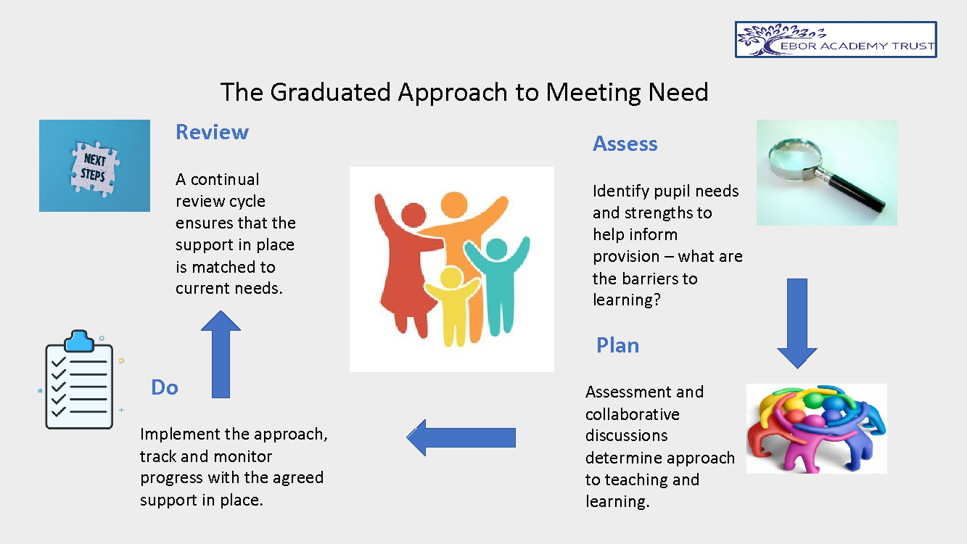

Pupils who have identified SEND are placed on the SEND register and parents/carers are informed. Support plans for children on the SEND register should be written in collaboration with parents/carers and any professionals that are involved. It is important that this follows a ‘done with’ rather than a ‘done to’ approach. Pupil voice is regularly collected to inform provision. Parents of learners with SEND have an opportunity to discuss their child’s progress with the school at least three times a year.

If a parent is concerned about SEND provision for their child, initial contact should be made with the class teacher. A meeting may be arranged, which could include the Headteacher and/or Deputy Head and/or SENCO/Inclusion lead, to discuss the concern.

The Special Educational Needs and Disability Information and Support Service (SENDIASS) is available to support parents in meetings concerning their child’s progress and welfare.

Roles and Responsibilities

  - Board of Trustees

The Trust’s Board of Trustees holds ultimate legal responsibility for all outcomes for pupils, including matters concerning SEND. The Board sets overall policy for SEND through this policy document and delegates, through a Scheme of Delegated Authority, operational and procedural SEND responsibilities to the following groups and individuals.
  - Local Governing Body

The local governing body of each school, together with the Headteacher/Head of School, have a responsibility for overseeing all aspects of the school’s work, including provision for children with special educational needs. They are also required to do their best to ensure that the necessary provision is made for any pupil who has special educational needs or a disability. They should determine the school’s general approach to provision for pupils with special educational needs and establish the appropriate staffing and funding arrangements.

An appointed representative from a school’s local governing body should be actively involved with the Headteacher and SENDCO during self-review, when considering the provision for pupils with special needs and implementation of the SEND policy within the school. It is best practice that SEND is part of the School Development Plan (SDP). It is also good practice for schools to have an improvement plan for SEND and for the local governing body to review progress of this plan.

  - Trust SEND Lead

The Trust SEND lead is responsible for developing a clear, strategic overview of SEND provision across the trust and for ensuring a trust-wide focus on improving outcomes for all pupils with SEND. The trust SEND Lead will:

a). maintain the trust SEND Policy in accordance with current statutory legislation and guidance
b). support SENDCOs in schools to ensure they are compliant and driving improvement for SEND in their individual school settings
c). work closely with the Safeguarding, Wellbeing and Behaviour Lead for the trust to ensure a holistic approach to meeting need and the accurate identification of SEND
d). provide a research-based SEND toolkit, regular updates, SENDCO networks and SENDCO clinics.
e). work in consultation with stakeholders, Board of Trustees, Executive Head, Heads of Schools to ensure that effective SEND provision is promoted at a trust wide level.
f). facilitate and deliver on a programme of professional development and training that matches needs presenting in schools.

5.4 Hub SEND Leads

‘Hub’ SEND Leads are experienced, practicing SENDCOs based in schools across the different Local Authorities in the trust. Each Local Authority in the trust has an allocated Hub SEND Lead and their role is to:
  - Meet with the Trust SEND Lead regularly to update on local SEND matters
  - share relevant Local Authority updates with other SENDCOs in their locality at network meetings
  - attend Local Area SENDCO networks
  - support good practice within their own locality

5.5 Headteacher/Head of School

The Headteacher has overall responsibility for the management of provision for SEND pupils in their school and keeps the governing body fully informed. The Headteacher also works closely with the SENDCO/Inclusion Lead to ensure provision and deployment of resources. The Headteacher is responsible for overseeing the:
- Designated teacher for SEND (SENDCO)
- Designated teacher for looked after pupils with SEND
- Designated Member of Staff for Safeguarding pupils
- Teaching Staff and Teaching Assistants working alongside SEND pupils

  - SENDCO/Inclusion Lead

Each school setting has a Special Educational Needs and Disabilities Coordinator (SENDCO) who works closely with all staff, the Headteacher, parents and outside agencies ensuring the best possible provision for pupils with special educational needs.
The SENDCO is responsible for:
a) overseeing the day-to-day operation of the school’s SEND policy
b) coordinating and advising on the provision for pupils with SEND
c) ensuring the involvement of parents from an early stage and liaising with parents of pupils with SEND
d) advising on a graduated approach to providing SEND support
- maintaining the school’s SEND register and SEND record keeping
- advising on the deployment of the school’s delegated budget and other resources to meet pupil needs effectively
- liaising with early years providers, other schools, educational psychologists, health and care professionals, and independent or voluntary bodies
- being a key point of contact with external agencies, especially the local authority and its support agencies
- liaising with next providers of education to ensure pupils and their parents are well informed about options and smooth transitions are planned
- supporting the professional development and effective deployment of teaching assistants, in liaison with Key Stage staff
- regularly liaising with the governors’ representative
- liaising with the relevant Designated Teacher where a looked after pupil has SEND
- attending SENDCO network meetings to remain informed of national and local updates to inform best practice
- ensuring that provision is in place for pupils with an Education, Health and Care Plan (EHCP) and these are reviewed annually in cooperation with the Local Authority and in collaboration with all relevant stakeholders, including parents/carers, holding interim or emergency reviews when identified needs have changed significantly
- contributing to the school’s Accessibility Plan

  - Teaching Staff

Teachers are responsible for the progress of all pupils in their class, including those identified as having SEND. We expect teaching staff to have high expectations of all pupils and offer a broad and balanced curriculum for all pupils. The identification of SEND is built into the overall approach to monitoring the progress and development of pupils. Teachers work closely with the SENDCO and teaching assistants to plan and assess the impact of support and interventions and how they can be linked to classroom teaching. Additional support and interventions cannot compensate for a lack of high-quality teaching.

  - Support Staff (Pastoral Workers, Teaching Assistants, Learning Mentors, Inclusion Teams)

Support staff should be fully aware of the school’s SEND policy and the procedures for identifying, assessing and making provision for pupils with SEND. They should support the work of the class teacher and support the inclusion of SEND pupils as far as possible. Support staff are also required to support SEND pupils, including supporting the delivery of pre-learning, over learning and relevant intervention programmes.

Admission Arrangements for Pupils with SEND

The Academy’s admissions arrangements ensure that schools do not discriminate or disadvantage pupils with a disability or SEND.

The Code of Practice requires a school to admit pupils who have an Education and Health Care Plan, where it is has been requested by parents as their school preference and named by the Local Authority (LA).

The LA must comply with this request and name the school in the EHCP but where relevant the academy can make representation to the local authority on the following grounds:
- it would be unsuitable for the age, ability, aptitude or SEND of the child; or
- the attendance/inclusion of the child would be incompatible with the efficient education of others at the school, or the efficient use of resources and no reasonable steps may be made to secure compatibility.

LAs will work closely with Academy schools so that any decisions on placement for a pupil with an Education Health and Care Plan reflect the individual circumstances of each child and the school. This will include guidance on making any reasonable adjustments and signposting to training and guidance available. The SENDCO in collaboration with parents and other key agencies will ensure appropriate provision is in place to support pupils with SEND entering the school.

Accessibility

Each academy must publish their Accessibility Plan on their website. SENDCOs should have a role in writing the Accessibility Plan. This will explain how the school plans to:
  - Increase the extent to which disabled pupils can participate in the curriculum
  - Improve the physical environment to enable disabled pupils to take better advantage of education, facilities and services
  - Improve the availability of accessible information to disabled pupils

The Local Authority is responsible for making suitable arrangements for safe transport to and from the academy for eligible disabled children.

Medical Needs

Some pupils with medical conditions may need support to access the curriculum. Pupils with medical conditions may also have special educational needs although this is not always the case. Where this is the case, this policy applies alongside our policy on ‘Supporting Pupils with Medical Conditions and Allergies including Administering Medicines in School.’

Evaluating Success

The success of each school’s SEND Policy and provision should be evaluated through:
- Monitoring of classroom practice by the Senior Leadership Team and the trust SEND Lead as part of Ebor reviews e.g., lesson observations, learning walks, collecting pupil and parent voice.
- Analysis of pupil tracking data and test results – for individual pupils and for cohorts
- Value-added data for pupils on the SEND register
- Monitoring of procedures and practice by the SEND governor
- School Self-Evaluation
- SEND reviews
- Monitoring the quality of support plans and review meetings
- The School Development Plan
- Successful transitions for school leavers with SEND to the next stage of their educational journey.

